|  |  |
| --- | --- |
| *school-learn-study-hat-graduate-512.png* | ***Study*** |

Read Chapter 5, section 5.1, 5.3, 5.5, 5.6, 5.7 and 5.10 of “How to Think Like a Computer Scientist: Learning with Python 3”:

<http://www.ict.ru.ac.za/Resources/cspw/thinkcspy3/thinkcspy3.pdf>

And then answer the following questions:

1. What is Boolean? Write down 3 different expression that results a Boolean type (i.e. 5 == 6)

-Boolean is either True or False.

-3 expression:

_9 == 10

_”b” + “ye” == “bye”

_8 == (6+7)

1. What is a flow chart? Draw flow chart for the following code snippet: (you can draw on a paper, take a picture of it)

if name == “Anh Quan":

print(“Hand some")

elif name == “Minh Duc":

even_more_handsome = True

else:

webbrowser.open(“<https://www.youtube.com/watch?v=04854XqcfCY>”)

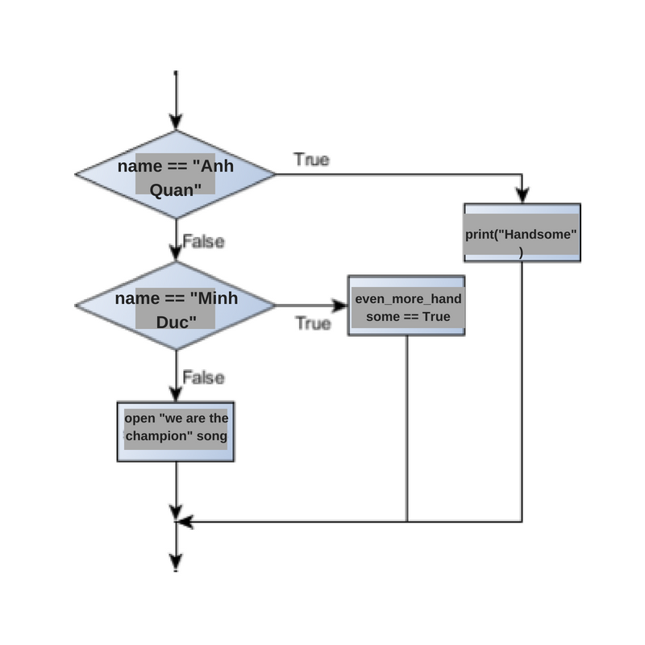

1. What is nested conditionals? Write a piece of code that uses nested conditionals

-Nested conditionals are loops within loops. In a conditional can contain branches and inside those branches they can contain other branches which have conditional statements too.

-Example:

if (a + b) > c:

print(“Hello”)

else:

if (a+b) < c:

print(“Bye”)

if (a+b) == c:

print(“Hi”)

else:

print(“No”)